## PROJECT BASED LAB REPORT

**On**

**Stock Market Analysis**

**Submitted in partial fulfilment of the Requirements for the award of the Degree of Bachelor of Technology**

## In

**Electronics and Computer Engineering**

**By**

**SOWMYA 190050079**

**SUSMITHA 190050056**

**M.MANASA LAKSHMI SANTHOSHI 190050106**



**Department of Electronics and Computer Engineering KONERU LAKSHMAIH EDUCATION FOUNDATION**

**(Deemed to be University u/s 3 of UGC Act 1956) Green Fields, Vaddeswaram– 522 502, Andhra Pradesh, INDIA**

## 2020-2021

**KONERU LAKSHMAIH EDUCATION FOUNDATION**

**DEPARTMENT OF ELECTRONICS AND COMPUTER ENGINEERING**



***CERTIFICATE***

This is to certify that this project based lab report entitled

**“Stock Market Analysis”**

is a bonafide work done by **SOWMYA( 190050079),SUSMITHA(190050056),M.MANASA LAKSHMI SANTHOSHI (190050106)** in partial fulfilment of the requirement for the award of degree in **BACHELOR OF TECHNOLOGY** in **Electronics and Computer Engineering** during the academic year 2020-2021.

**LECTURE INCHARGE M.S.G.PRASAD**

**Kiran Kumar HEAD OF THE DEPARTMENT**

**KONERU LAKSHMAIH EDUCATION FOUNDATION**

**DEPARTMENT OF ELECTRONICS AND COMPUTER ENGINEERING**



***DECLARATION***

We hereby declare that this project based lab report entitled

**“Stock Market Analysis”**

has been prepared by us in partial fulfilment of the requirement for the award of degree “**BACHELOR OF ELECTRONICS AND COMPUTER ENGINEERING**” during the academic year 2021-2022.

I also declare that this project based lab report is of our own effort and it has not been submitted to any other university for the award of any degree.

**SOWMYA 190050079**

**SUSMITHA 190050056**

**M.MANASA LAKSHMI SANTHOSHI 190050106**

**Date:**

**Place:**Vaddeswaram

**CONTENTS**

|  |
| --- |
| **1.ABSTRACT**  **2.ACKNOWLEDGEMENT**  **3.INTRODUCTION**  **3.1 INFORMATION ON STOCK** |
| **3.2. PROBLEM DEFINITION** |
| **3.3. PROJECT PURPOSE** |
| **3.4. PROJECT FEATURES** |
| **3.5. MODULES DESCRIPTION**  **5.PROBLEMS FOR THE ANALYSIS** |

**6.CODE WITH OUTPUT**

**7.SNAPSHOT**

**8. CONCLUSION**

**9..REFERENCES**

# ACKNOWLEDGEMENT

We also sincerely thank our project guide **Kiran Kumar** , for providing his extreme support in fulfilling this project

We express our gratitude to **Dr. M.S.G Prasad,** Head of the Department of Electronics and Computer Engineering for providing us with adequate facilities, ways and means by which we are able to complete this project.

We would like to place on record the deep sense of gratitude to the honourable Vice Chancellor, K L E F for providing the necessary facilities to carry the concluded work.

Last but not the least, we thank all Teaching and Non-Teaching Staff of our department and especially my classmates and my friends for their support in the completion of our work.

**SOWMYA 190050079**

**SUSMITHA 190050056**

**M.MANASA LAKSHMI SANTHOSHI 190050106**

**ABSTRACT**

Stock is an unpredictable curve. Prediction in stock market is covered with the complexity and instability. The main aim for the persuasion of the topic is to predict the stability in the future market stocks. Many researchers have performed their research on the movement of future market evolution. Stock consists of fluctuating data which makes data as an integral source of efficiency. Impact on the same chances the efficiency of the prediction. In the recent trend of Stock Market Prediction Technologies machine learning has integrated itself in the picture for deployment and prediction of training sets and data models. Machine Learning employs different predictive models and algorithms to predict and automate things of requirement. The Paper focuses on the use of Regression and LSTM to predict stock values.

**INTRODUCTION**

## INTRODUCTION INFORMATION ON STOCK

We all have heard the word stock one way or the other. Particularly stock is related with the associates and companies which are commercialized and are to settling in the world of marketization. The other word used for stock is share which is prominently used in day to day life. People even term is as an investment plan and its something people see as a long term investment that secures and provides an abundant funds during the retirement age.

Buying a company stock is purchasing a small share of it. People invest on the same to get a long term benefit which they think is less value for now but has to potential to grow with the time. Its an investment that provides the long time run and deals with long time goals with the fair objectives. The value of share you invest today has to give you an yield of best tomorrow but its not the same.

Market is unpredictable so are the resources and the factors that are taken to drive it off or on on the set. Its never been on the same level and the pattern of the same is still unpredictable till the time. Some closeness and prediction method had been derived and approximates values and the rough figures are generated hoping for the best but all of the resource can’t be trusted and are still unpredictable in nature.

Knowing the market situation and researching on the same is the best way to find the reliability for which there are many agents who have taken the same as a profession and are making a fortune out of it. They predict and advise but the advisory cost and the charge is higher and the stock evaluation is never less the same.

Market is changing in an instantaneous rate even in a day there are many highs and lows in the market and having said the resources and the timing the external and internal agent. Stock is a fascinating resource to start with.

Stock in other term is defined as the fair share or the ownership representation explaining the security measures and the agreement between two parties which are an individual and the company. Stock is there from the start and due to its tendency of uncertainty it has been a word of fancy. People researching on the same and implementing on the daily basis had made a fortune out of it. There are various agents available in market for making you understand and invest on the same and the charges of the same are hectic and insanely expensive.

The main resources for the company is the fund to carry out the daily work and create a profit out of it. In time of need for an higher budget estimation and to overgrow from the resources they need the finance and undergoing a finance loan for approval, passing and having one is hectic and the banks are vultures for which the interest rate is higher than the other form of investment hence limiting the margin of the product.

Stock is an other way for company to collect revenue and boost up the production for the upper yield and to gain the most out of the business plan for the bigger pictures. This is found to be an effective way to invest and grow in the commercial field and a better alternative to tackle the financial crisis during the requirement.

For an investor its a risk phenomenon where they invest their saving and hope it brings back the return in higher yield. If the evaluation of the same increases then the stock evaluation and its price increases causing the financial gain to both the parties. In Indian Society it is even consider as a side point business and people believe it as a hand of luck.

When an individual purchases a company stock then they’re referred as a shareholder and they will get a share out of the same as they have invested in their profit or the gain. A investor can sell and buy the stock as per their needs. They can share their stock to their respective or the other individuals where as there are many stock brokers available out in the firm playing with the same.

## PROBLEM DEFINITION

Stock is an unpredictable curve that had been in picture ever since. Its essence had been ever long living and indulging. It had grown its popularity with respect to time. People are more fascinating and interested on the same then before times. Same for the case for the organization. Organization had created it as a better source of revenue generation rather than investing and taking a loan approval from the bank It's way efficient and less hectic from the firm point of view.

Stock is unpredictable and its been the same from the start. Its way of escalating and deescalating had been phenomenon and experiencing the same is the best integral part of it. It has its upper hand and flexibility with the changes that has the chances of uprising as well as crashing the whole market. Its easily defined in few words but making an essence and understanding the same is way more hectic and time consuming.

Simpler it sound complex are its phenomenon and integrating the same. Its has its whole different sets of dependencies and integration from different agents which fluctuate the same in the market. Finding an accurate and getting the exact values out of the same is still unaligned and no particular model of the same is seen in the market value.

Finding the closest and getting an accurate proximate value out of such an unpredictability is a problem in itself.

Merging of the data getting the best prediction to increase the efficiency alongside considering the different expects of the moderator is tough and we took the same in consideration and implemented with every aspect to generate the best out of the same and get a result that can be better interrupted and the efficiency remains the same with the value of different aspects of creating an impact of reducing the risk and influencing the same over the time period to gain the most out of it.

This is totally based on Machine Learning Algorithm to proceed and provide an effective result. Getting the data and processing it and generating a forecast for three days is the problem statement that we worked on.

## PROJECT PURPOSE

Stock market prediction is a prediction system software that illuminate the risk that undergoes during the investment in stock market. It predicts the stock rates and its rate of exchange acknowledging the basic understanding and the statistical analysis in front of users.

Data is considered as the digital fuel that gives the possibilities of higher yearn and gives the upcoming terms. Knowledge is power and same holds correct with the stock. Stock is unpredictable and over-changing its dynamic in nature. The rise and fall of the same is uneven and can’t be classified so easily. Dependencies of the same deals with flexible resources and the agents behind it.

Investment during a fiscal day determines the opening stock market for the next day. It has its dependencies and is total integration with the level of finances and revenue generation. The stock is tremendous and hectic in nature. The main theme of the project is to predict the turning curves and bring the predictability method and undergo the process and algorithms to conclude to a viable resource source.

Everything flows a pattern. Pattern is the way of derivation and so holds true for the stock too. Stock in day to day life follows a pattern movement. Increase in some resource can increase the price of some whereas decrease the price rate for the others, The source and the outcome are derived on the polarity basis which can either be positive, neutral or an negative flow. Correlation of the given polarity is determined and an effective source and reliability is established.

This project helps in bridging the resources and empowering the people to know and trade the most out of stock and understand the generation and the vulnerabilities that has to be seen and predicted. The enhancement of the same is done with the resource graph which makes an user or the customer to analyses the same and take the needs and important details before dealing and consider those things for the yield that the person is willing to invest on. Forecasting of the stock prediction is done by the available data source and the prediction is done for the upcoming week. The predictability itself is a challenge and that’s the main purpose of the report.

## PROJECT FEATURES

Features deals with the flexibilities and the top marks that one can present. The project was headed with the resource available and the most that the company demands and that is finance. Taking about finance and learning on the same gave an idea on the fiscal and stocks. So the featuring of the idea came with handling and automating the resource which other agents are making fortune out of it.

Knowledge is a bliss and learning is the curiosity where as outcome is the expectation so the resource deals with the importation and extraction of multiple machine learning algorithms to learn, process and yield the result to derive and conclude a possible outcome set that is effective and generative in nature.

There are various model that outflows in market which are trying it’s best on creating a resource and give the predictability to most of it accurate but everything is not the same and the conclusion of the same are not ideal. The efficiency varies as the variation in the stock market and it’s prediction.

The project was purposed with the intent sole to make and undergo the following way of computing. The first deals with the data extraction that is done with clearing of data and its chunks from the database or the dataset. The second flow is the training from the source training is done and classified. During the same supervision is done and the last part is the generation of the yield which provides the result after computation of the same.

Salient features included are the Visualization and the prediction that gives a boost. Uses of different forecasting algorithm to forecast that holds true and are suffice in nature to yield to the positive resource source. Diving and initializing the expects that needs to be considered. Mitigating the risk factors to bridge and uplift the investment.

Analyzing and utilizing the same to support the live environment. Keep a track of progressive result and it’s evaluation on day to day basis to find the flows and the level of integration. Automating for the ideas and making it most by using feasible algorithms which can undergo learning and implement the updates in itself to summon the efforts that one needs to take for the best.

## MODULES DESCRIPTION

**DATA SET**

This is the fundamental module before starting of the project. The dataset is a group of data that are mended together to show the data variations in a time span to undergo further estimation and the source of the resources and its outcome for the later time of evaluation. It generates the result optimization and gives a feasible time period to customize and get the flow to the derivation.

This increases and are used in the level of research and finding the best suitable resource out of the same the resources has to be finely estimated and derived for the best possible outcome and the finest the value become the better is the level of extraction and closure is the best yield values that needs to be considered.

**DATA ABSTRACTION**

Abstraction is the finding of the resource to its best to categorized the above dataset and learning the best out of it. Abstraction of the data is the integral part to the flow. All the data are a huge set of chunks which on processing can limitize the yield result and the computational mean too. Thus with the available resources the data yield had to be derivative.

Abstraction of the dataset is to customize the data set and finding the best suitable constraints to take into consideration and the unwanted resources are the dump which will be dumped and the supreme cluster is created with the valuable constrains and a pattern is needed to be derived from the same.

Data are cleared on this level for the beginning of the process. The valuable data are the set that brings the value to the data set for a better understanding and giving a better yield and production by evaluating the same.

This is a feature abstraction module to extract the featuring of the dataset. This is a feature model process where all the feasible resources are categorized and the same will be in use for the featuring.

**TRAINING DATASET**

After the abstraction of the data and clustering of the same. The machine had to be trained for which the training data plays the important role. There are thousands of machine learning algorithms that are into place and evolving with the same. The best to the practice of machine learning is to yield the result and the content to derive what’s needed with the time frame.

This is a supervised learning form where the input are passed so that the system learns from the same. Various variants of inputs are passed which were stored in the dataset. Every resource is considered and taken into consideration. After considering the whole set of information and the resource the machine tries to learn from the passed dataset. The dataset has to be wide and versatile. After considering the learning it tries to integrate with the same type and flow like the same as the human mind and creates a pattern and the links between the same.

**TEST DATASET**

These are the sets of data that gives the result after learning from the data. This is the test generation with the output result. Results are generated in each phase of testing. This is also termed as the testing phase. Now a new set of datasets are passed which are deliberately like the training dataset and the efficiency of the same is calculated.

Over-Fitting of the dataset. Validation of the same with the effective constraints and hyper parameters are checked. This phase is training and the output is evaluated with the set of training. After each process of computation the set of data are trained and efficiency of the same is measured and is evaluated with the others.

Various batches of the test is implemented to get to the level of accuracy and derive result to fetch and yield for the best performance and to be true to the effectiveness of the data which is not biased with any constrains available. This determines the efficiency of the system which is must for the predictions.

**4.SOFTWARE REQUIREMENT**

**4.1. Jupyter Notebook**

The Jupyter Notebook is an open-source web application that allows you to create and share documents that contain live code, equations, visualizations and narrative text. Uses include: data cleaning and transformation, numerical simulation, statistical modeling, data visualization, machine learning, and much more.The Jupyter Notebook App is a server-client application that allows editing and running notebook documents via a web browser. The Jupyter Notebook App can be executed on a local desktop requiring no internet access (as described in this document) or can be installed on a remote server and accessed through the internet. In addition to displaying/editing/running notebook documents, the Jupyter Notebook App has a “Dashboard” (Notebook Dashboard), a “control panel” showing local files and allowing to open notebook documents or shutting down their kernels.

**5.PROBLEMS FOR THE ANALYSIS**

* Import the financial data using quandl for the following companies:
* Apple
* Amazon
* Microsoft
* Google
* Perform fundamental data analysis
* Fetch the last one year’s data
* View the values of Apple’s stock
* Display the plot of closing price
* Display the stock trade by volume
* Plot all companies’ data together for closing price
* Perform Daily Return Analysis and show the relationship between different stocks
* Plot the percentage change plot for Apple’s stock
* Show a joint plot for Apple and Google
* Use PairPlot to show the correlation between all the stocks

Perform risk analysis

**6.CODE WITH OUTPUT**

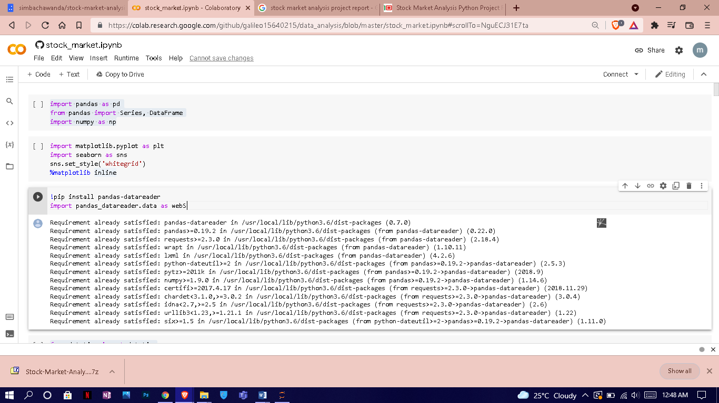

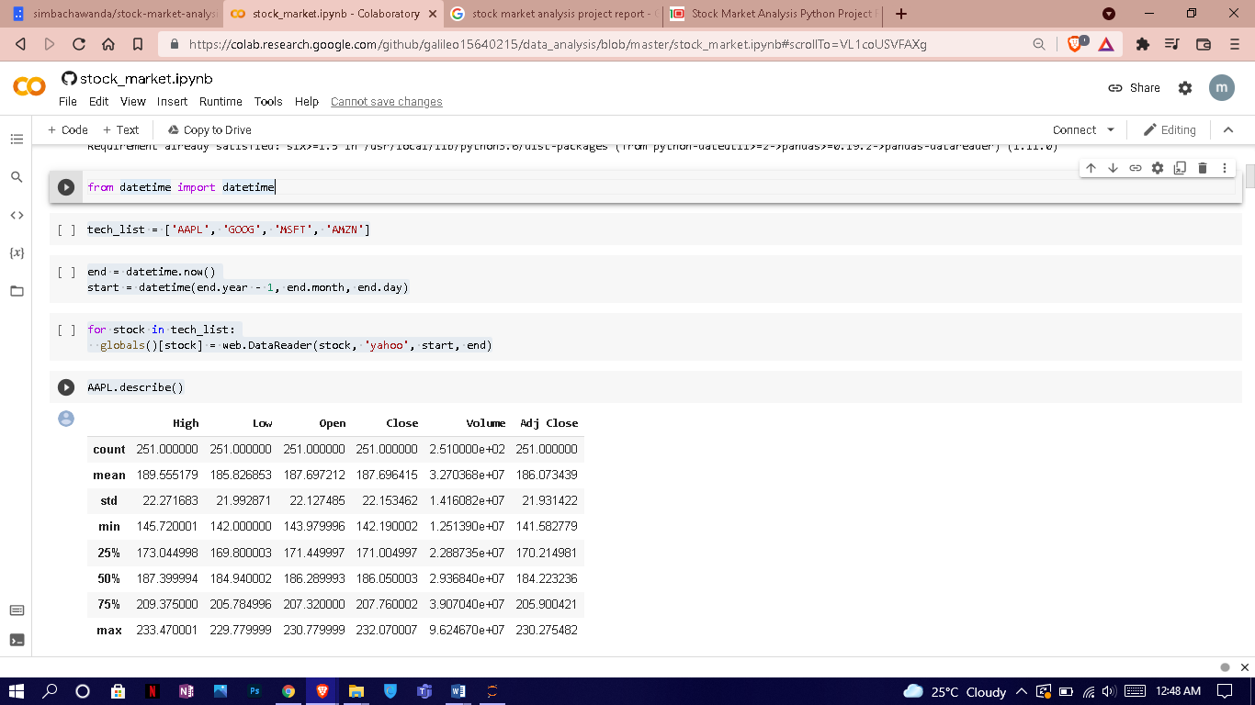

**7.SNAPSHOT**

**Summary Stats**

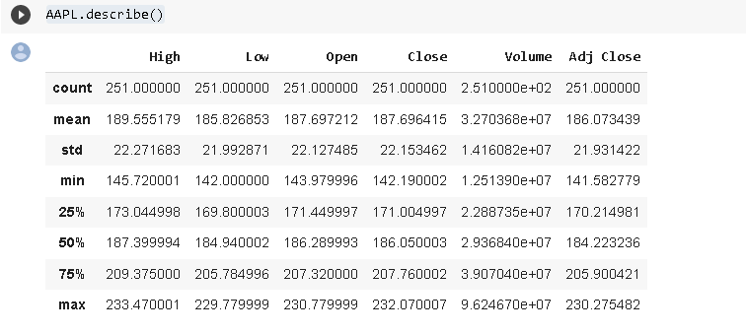

**Historical view of the closing price**

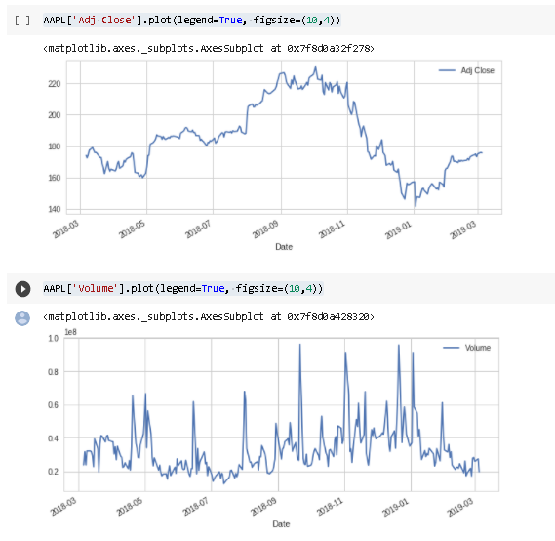

**Average of the various stocks**

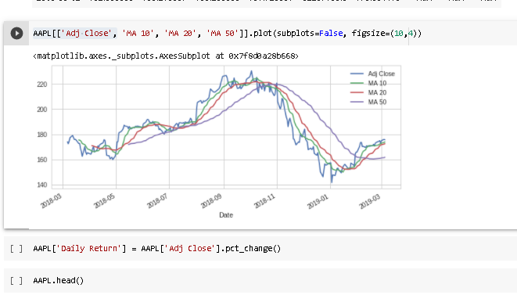

**The daily return of the stock on average**

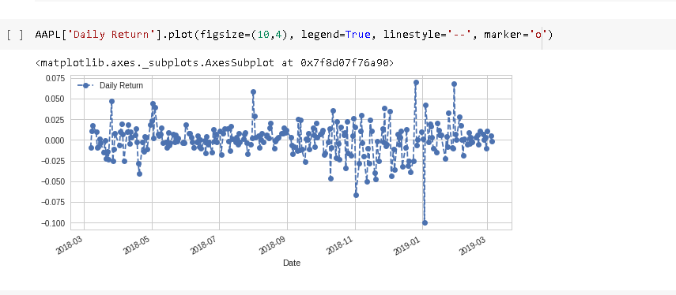

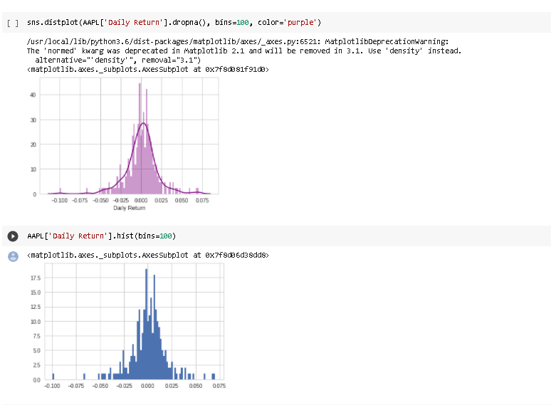

**The correlation between different stocks closing prices**

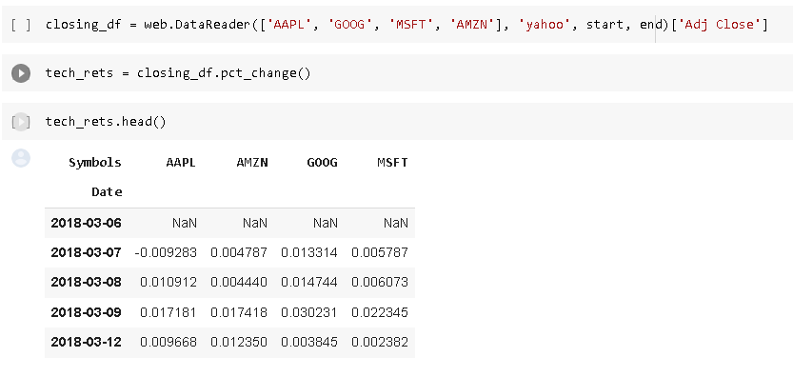

Above we can see all the relationships on daily returns between all the stocks. A quick glance shows an interesting correlation between Google and Amazon daily returns. It might be interesting to investigate that individual comaprison. While the simplicity of just calling sns.pairplot() is fantastic we can also use sns.PairGrid() for full control of the figure, including what kind of plots go in the diagonal, the upper triangle, and the lower triangle. Below is an example of utilizing the full power of seaborn to achieve this result.

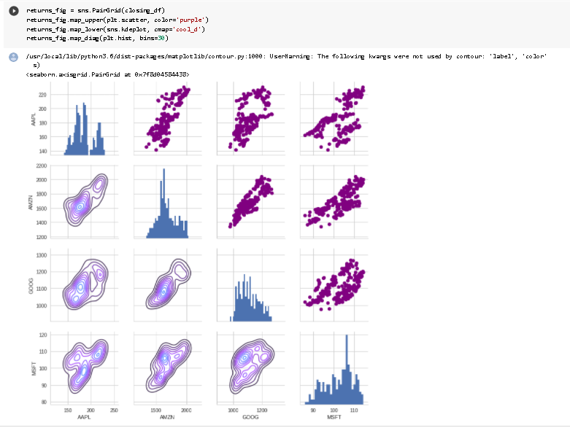

**8. CONCLUSION**

## CONCLUSION

To conclude stock is an unpredictable mechanism which follows the segments of chain and the dependencies of the same are unpredictable. It is defined to be an curve which keeps on changing and turning the price from low to high and vice-versa.

As the integration of the same is higher with other dependencies so leaving one dependencies compromises the level of accuracy. Accuracy is not the term used over in stock as the actual prediction is not possible for any fiscal days it keeps on changing and turning the tables day and night. Having higher component assets and the dependencies makes it more feasible and flexible in nature causing it even harder to predict. The approx value are taken into consideration and the hit or profit or the gain rate is calculated for the same.

In the project various high level machine learning algorithms are implemented and integrated and the output is generated from the same making a user visible with the outputs in the form of graph which makes it easier for them to see and interpret what’s the scenario and they can decide on the same to invest and get the benefit out of it,

The proposed software takes the raw set of data from the dataset or the .csv file and process it. The cleaning and cleansing of data is done and then further processed to gain the effective outcomes. After the computational mean the output is displayed in the screen in the form of graph.

# 9.REFERENCES

1. K. Senthamarai Kannan, P. Sailapathi Sekar, M.Mohamed Sathik and P. Arumugam, “Financial stock market forecastusing data mining Techniques", 2010, Proceedings of the international multiconference of engineers and computerscientists.
2. Tiffany Hui-Kuang yu and Kun-Huang Huarng, “A Neural network-based fuzzy time

series model to improveforecasting”, Elsevier, 2010, pp: 3366-3372.

1. Md. Rafiul Hassan and Baikunth Nath, “Stock Market forecasting using Hidden Markov Model: A New Approach”, Proceeding of the 2005 5th International conference on intelligent Systems Design and Application 0-7695-2286-06/05, IEEE 2005.
2. Bonde, Ganesh, and Rasheed Khaled. “Extracting the best features for predicting stock prices using machine learn- ing.” Proceedings on the International Conference on Artificial Intelligence (ICAI). The Steering Committee of The World Congress in Computer Science, Computer Engineering and Applied Computing (WorldComp), 2012.
3. P. Hajek, Forecasting Stock Market Trend using Prototype Generation Classifiers, WSEAS Transactions on Systems, Vol.11, No. 12, pp. 671-80, 2012.
4. Hagenau, Michael, Michael Liebmann, Markus Hedwig, and Dirk Neumann. "Automated news reading: Stock price prediction based on financial news using context- specific features." InSystem Science (HICSS), 2012 45th Hawaii International Conference on, pp. 1040-1049. IEEE, 2012.
5. Kyoung-jae Kim, Ingoo Han. “Genetic algorithms approach to feature discretization in artificial neural networks for the prediction of stock price index”. Expert Systems with Applications, Volume 19, Issue 2, 2000, Pages 125-132, ISSN 0957-4174.
6. Leung, Carson Kai-Sang, Richard Kyle MacKinnon, and Yang Wang. “A machine learning approach for stock price prediction.” Proceedings of the 18th International Database Engineering & Applications Symposium. ACM, 2014.